**A**

**SEMINAR REPORT**

**ON**

**SALESFORCE**

Submitted in the partial fulfilment of the requirements for the award of degree of

**BACHELOR OF TECHNOLOGY**

**IN**

**COMPUTER SCIENCE AND ENGINEERING**

**BY**

**ONTERU RAJYALAKSHMI 20JU1A05A7**

**KONKALA MOUNIKA 20JU1A0575**

**KALANGI PRATHYUSHA 20JU1A0599**

**MADDELA SAI CHARAN 20JU1A05C1**

**UNDER THE ESTEEMED GUIDANCE OF**

**Mr.C.JAYARAMULU,M.Tech(Ph.D)**

**Associate professor**



**DEPARTMENT OF COMPUTER SCIENCE AND ENGINEERING**

**KRISHNA CHAITANYA INSTITUTE OF TECHNOLOGY AND SCIENCES**

**(Approved by AICTE,New Delhi &Affiliated To JNTU KAKINADA,Accredited by NAAC) Devarajugattu, Peddaraveedu Mandal, Prakasam (District),A.P.**

**(2020-202**

**CERTIFICATE**

This is to certify that the report entitled **Salesforce** the bonafied work carried out by O.RAJYALAKSHMI(20JU1A05A7),K.MOUNIKA(20JU1A0575),K.PRATHUSHA(20JU1A0599),M.SAI CHARAN(20JU1A05C1) in partial fulfilment of the requirements for the award of degree of bachelor of technology in the department of computer science and engineering. From JNTUK during the year 2023-2024.

**PROJECT GUIDE: HEAD OF THE DEPARTMENT**

C.JAYARAMULU, M.Tech Dr.J.V.ANILKUMAR, M.Tech(Ph.D)

Associate professor HOD OF CSE DEPARTMENT

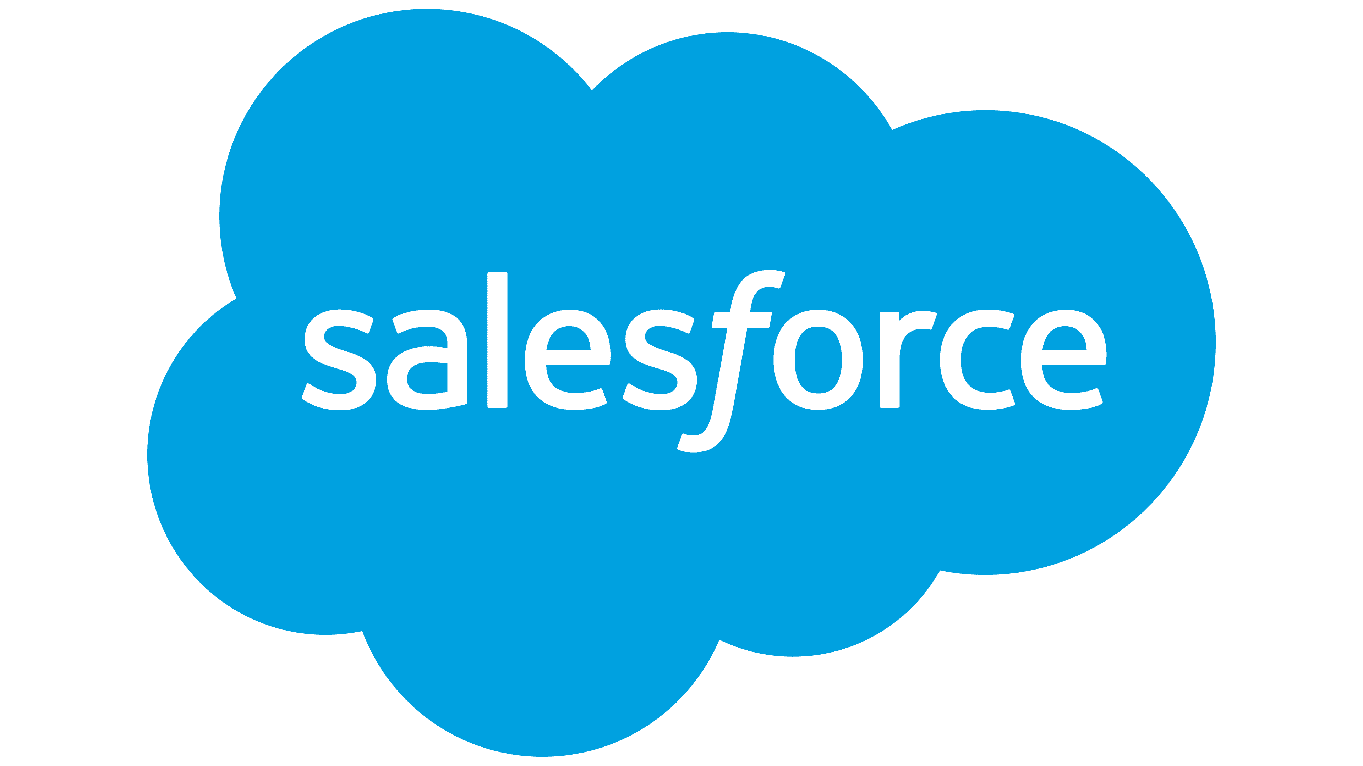

CONTENTS:

* Cloud computing
* CRM
* Introduction
* History
* Features
* Architecture
* Working process
* Job roles
* Career path
* Job oppurtunities
* Hiring companies
* Packages
* Installation
* Conclusion

**CLOUD COMPUTING:**

* It is the delivery of computing services including servers,storage databases,networking,software analytics over internet
* Cloud computing is a technology to store , manage , process, and access the internet instead of local server or computer hard drives
* There are different types of services

1.IAAS- Infrastructure as a service

2.PAAS – Platform as a service

3.SAAS – Software as a service

**1.IAAS:**

* It is also known as hardware as a service
* It is a type of cloud computing service that offers storage,databases,memory and networking
* It is mostly used by admins

EX:-microsoft azure

**2.PAAS:**

* It provides software and hardware tools to users over internet
* It provides platform to develop applications
* It mostly used by developers

EX:- google app engine(GAE)

**3.SAAS:**

* It is also known as “on demand software”
* Instead of installing and maintaining software you can simply access via internet
* It is used by the end users

**CRM:**

* It is a customer relationship management
* It is a technology for managing all your company relationships and interactions with current and future customers
* Goal :- to improve business relationships
* A CRM helps company stay connected to customers,streamline processes, and improve profitability

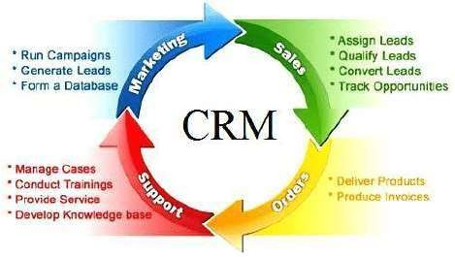

* **CRM is mainly used in**

**1 .**Marketing

2.Sales

3.Support

4.order

**INTRODUCTION:**

* Salesforce is one of the best cloud based CRM platforms.
* Salesforce is a software as a service or saas.
* It means there is no need to install the software or server to work on. Users can simply singnup in salesforce.com and start running the business instantly.
* Salesforce was started as a CRM software, but today it provides various products and software solutions to users and developers.

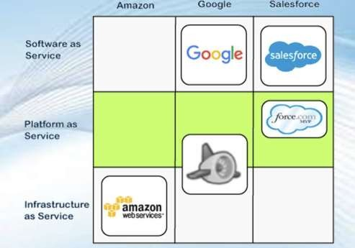

**HISTORY:**

* The salesforce development was started in 1999 by Marc Benioff, Parker Harris, Frank Dominguez, and Dave Moellenhoff ,developers with the same vision of Salesforce's CRM.
* In the year 2005, Salesforce introduced its AppExchange Service.
* The service was designed to offer a platform to third-party developers to develop their applications and provide those apps to salesforce customers.
* In the year 2008, Force.com- "a salesforce development platform that allows developers to build applications," has released.
* In the year 2014, the company launched the Trailhead, a platform to empower anyone to learn new skills.

**FEATURES:**

Salesforce is a cloud-based customer relationship management (CRM) platform that offers a wide range of features to help businesses manage their sales, customer service, marketing, and more. Here are some key features of Salesforce:

**1.contact and lead management**

Salesforce allows users to store and manage customer information, including contacts and leads, in a centralized database.

**2.oppurtunity management:**

Users can track and manage sales opportunities, including details such as deal size, stage, and probability of closing.

**3.sales automation:**

Automation tools help streamline the sales process, automate repetitive tasks, and ensure a more efficient sales workflow.

**4.workflow rules and process builder:**

Salesforce allows users to create automated workflow rules and processes to trigger actions based on certain criteria.

**5.dashboards and reports:**

Users can create customizable dashboards and reports to gain insights into sales performance, customer engagement, and other key metrics.

**6.email integration:**

Salesforce seamlessly integrates with email platforms, allowing users to track emails, schedule follow-ups, and maintain communication records within the CRM.

**7.AI-powered insights:**

Salesforce incorporates artificial intelligence (AI) through features like Einstein Analytics, providing predictive analytics, personalized recommendations, and data-driven insights.

**8.mobile accessibility:**

The platform is accessible through mobile devices, enabling users to access and update CRM data on the go.

**9.customer service and support:**

Salesforce Service Cloud offers tools for customer service and support, including case management, knowledge base, and customer self-service portals.

**10.marketing automation:**

Salesforce Marketing Cloud enables users to create and execute marketing campaigns, track customer engagement, and analyze marketing performance.

**11.integration capabilities:**

Salesforce can integrate with a variety of third-party applications and services, allowing for a seamless flow of data between different systems.

**12.community portals:**

Salesforce Community Cloud enables the creation of online community portals for customers, partners, and employees, fostering collaboration and engagement.

**13.appexchange marketplace:**

The Salesforce AppExchange offers a vast marketplace where users can find and install third-party apps and extensions to extend the functionality of the platform.

**14.security compliance:**

Salesforce provides robust security features, including user authentication, data encryption, and compliance with industry standards and regulations.

**15.customization and extensibility:**

Users can customize Salesforce to suit their specific business needs through point-and-click tools, and for more advanced customization, there's support for Apex (a programming language) and Visualforce (a markup language).

**CORE ARCHITECTURE:**

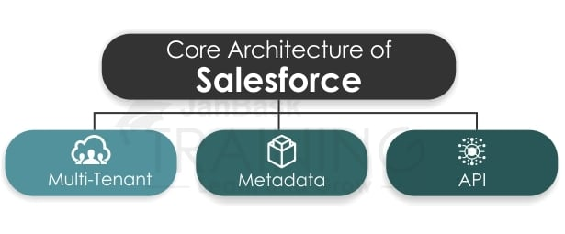

There are 3 different types of core architecture of Salesforce:-

1. MULTI-TENANT
2. META DATA
3. API

1. **MULTITENANT:**

* Salesforce architecture is so popular because

of its **multitenancy**

* + *The multitenant architecture means* ***one common application for multiple groups or clients***. In such architecture, multiple clients use the same server, but their oaks are isolated from each

other

* It means the data of one client is secure and isolated from other groups or clients.

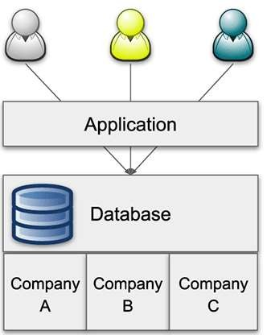

* The development cost is much high in single- tenant architecture than the multi-tenant because, in single-tenant, each user on the application and the maintenance cost is also

owned by the single user.

1. METADATA:

* The Salesforce platform follows the meta-data development model.
* Salesforce stores the metadata in the shared database along with the data. It means it stores the data as well as what data does.
* the tenant-specific data ensures that the common data is only shared with one tenant, not with another tenant or group.
* This ensures the security of the data even in the shared database.
* The security issues get resolved with the multitenant architecture because all data is stored on different levels in the form of metadata, i.e., data above data.

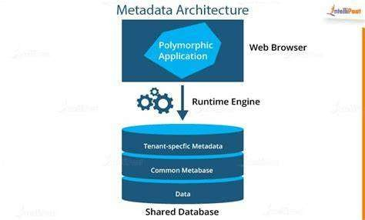

* We can understand it will an example, such as if there are three clients A, B, and C who contain the shared database in the salesforce platform.
* These groups can access their metadata from the shared data.
* Therefore, each client will have separate metadata.
* This separate metadata makes ensure each client shares his data only, not others.
* This increases the security of the shared database with the developer's productivity.

**3.API:**

* The salesforce metadata-driven model allows the developers to create their applications easily with the help of various tools.
* But sometimes developers need some more functionalities for their apps to make some modifications.
* To make such modifications, salesforce provides a powerful source of the APIs.
* These APIs helps the developers to customize the Salesforce mobile application.
* These APIs allows the various bits of programming to interface with each other and trade data.
* Without knowing many details, we can connect our apps with other apps.
* The API provides a simple but powerful, and open way to programmatically access the data and any app running on the salesforce platform.
* These APIs helps the developers to access apps from any location, using any programming language that supports Web services, **like Java, PHP, C#, or .NET**

**WORKING PROCESS:**

The working process of Salesforce involves several key steps and components that collectively support various aspects of customer relationship management (CRM). Here's an overview of the typical working process of Salesforce:

**1.user access and authentication:**

Users access Salesforce through a web browser or mobile app, where they log in using their credentials. Salesforce employs secure authentication measures to ensure data security.

**2.dashboard home page:**

Upon logging in, users are presented with a personalized dashboard and home page. Dashboards can be customized to display key performance indicators (KPIs) and other relevant information.

**3.sales automation:**

Salesforce supports sales automation by allowing users to create and automate workflows. This includes setting up rules and processes that trigger actions based on specific criteria, such as sending emails, updating records, or assigning tasks.

**4.communication and collaboration:**

Users can log emails, calls, and meetings within Salesforce, providing a comprehensive view of customer interactions. This helps in maintaining a centralized communication history and collaborating effectively within the platform.

**5.reports and analysis:**

Salesforce provides robust reporting and analytics tools. Users can create custom reports and dashboards to analyze data, track performance, and gain insights into various aspects of their business.

**6.integration with external systems:**

Salesforce can be integrated with other systems and applications to facilitate a seamless flow of data. This may include integration with email platforms, marketing automation tools, ERP systems, and more.

**7.AI-powered insights:**

Salesforce incorporates artificial intelligence through features like Einstein Analytics. This provides predictive analytics, personalized recommendations, and insights derived from the data within the CRM.

**8.marketing insights:**

Users can leverage Salesforce Marketing Cloud for planning, executing, and analyzing marketing campaigns. This includes email marketing, social media campaigns, and other marketing activities.

**9.customer service and support:**

Salesforce Service Cloud supports customer service and support functions. It includes case management, a knowledge base, and tools for managing customer inquiries and issues.

**10.customization and development:**

Organizations can customize Salesforce to meet their specific needs. This involves using point-and-click tools for simple customizations and, for more complex requirements, utilizing Apex (a programming language) and Visualforce (a markup language).

**11.continuous improvement:**

Organizations using Salesforce typically engage in continuous improvement by monitoring performance, gathering feedback, and making adjustments to their Salesforce configuration to better meet their evolving needs.

**JOB ROLES:**

Salesforce is a versatile platform with a wide range of functionalities, and as a result, it has created a variety of job roles across different domains. Here are some common job roles associated with Salesforce:

**1.Salesforce Administrator:**

Responsible for the day-to-day configuration, maintenance, and support of Salesforce. They manage user access, security settings, workflows, and data integrity.

**2.Salesforce Developer:**

Specialized in customizing and extending Salesforce functionalities through coding. They use languages like Apex (similar to Java) and Visualforce (markup language) to create custom applications and features.

**3.Salesforce Consultant:**

Works with clients to understand their business needs and designs Salesforce solutions to meet those requirements. They may specialize in areas such as sales, marketing, service, or community cloud consulting.

**4.Salesforce Architect:**

Focuses on designing and implementing scalable and maintainable Salesforce solutions. They have a deep understanding of Salesforce capabilities and guide the overall architecture of Salesforce implementations.

**5.Salesforce Business Analyst:**

Analyzes business processes and requirements, working closely with stakeholders to ensure that Salesforce solutions align with the organization's goals. They often bridge the gap between business users and technical teams.

**6.Salesforce Project Manager:**

Manages Salesforce implementation projects, including planning, coordination, and communication. They ensure that projects are completed on time and within budget, while meeting business objectives.

**7.Salesforce Solution Engineer:**

Collaborates with sales teams to demonstrate how Salesforce can meet the specific needs of potential clients. They provide technical expertise during the sales process.

**8.Salesforce Trainer:**

Educates users within an organization on how to effectively use Salesforce. This role involves creating training materials, conducting workshops, and providing ongoing support.

**9.Salesforce Data Analyst:**

Focuses on analyzing and interpreting data within Salesforce to provide insights that can inform business decisions. They may use tools like Salesforce Reports and Dashboards or external analytics tools.

**10.Salesforce Quality Assurance Analyst:**

Ensures the quality of Salesforce implementations by testing customizations, configurations, and integrations. They identify and report bugs and work closely with developers to resolve issues.

**11.Salesforce Marketing Specialist:**

Specializes in using Salesforce Marketing Cloud or other marketing automation tools to plan, execute, and analyze marketing campaigns. They may focus on lead generation, email marketing, and customer segmentation.

**12.Salesforce Community Manager:**

Manages and facilitates online communities built on the Salesforce Community Cloud. They engage with users, ensure community health, and drive collaboration.

**13.Salesforce Support Specialist:**

Provides ongoing support to Salesforce users, addressing inquiries, troubleshooting issues, and ensuring that users can effectively leverage the platform.

**14.Salesforce Integration Specialist:**

Specializes in integrating Salesforce with other systems and applications. They design, implement, and maintain seamless data flows between Salesforce and external platforms.

**15.Salesforce Mobile App Developer:**

Focuses on developing and optimizing mobile applications that integrate with Salesforce, providing users with a mobile-friendly experience.

**CAREER PATH:**

Salesforce is a leading cloud-based Customer Relationship Management (CRM) platform that has revolutionized the way businesses operate. As a result, there is a growing demand for skilled Salesforce professionals, making it an excellent career choice for those seeking opportunities in the technology industry.

Here are some of the most popular career paths in Salesforce:

**1.Salesforce Administrator:**

A Salesforce Administrator is responsible for managing and maintaining the Salesforce organization for a company. This includes tasks such as setting up user accounts, configuring the system, and resolving issues. Salesforce Administrators typically have a strong understanding of Salesforce concepts, as well as experience in IT administration.

**2.Salesforce Developer:**

A Salesforce Developer is responsible for building and customizing Salesforce applications. This includes tasks such as developing Apex code, creating Visualforce pages, and integrating Salesforce with other systems. Salesforce Developers typically have a strong background in programming, as well as experience with Salesforce development tools.

**3.Salesforce Consultant:**

A Salesforce Consultant is responsible for advising companies on how to best implement and use Salesforce. This includes tasks such as conducting needs assessments, designing and implementing Salesforce solutions, and training users. Salesforce Consultants typically have a deep understanding of Salesforce best practices, as well as experience in project management and consulting.

**4.Salesforce Architect:**

A Salesforce Architect is responsible for designing and overseeing the overall architecture of a Salesforce solution. This includes tasks such as defining data models, designing security controls, and ensuring that the system is scalable and maintainable. Salesforce Architects typically have a strong understanding of Salesforce architecture principles, as well as experience in designing and implementing complex IT systems.

**5.Salesforce Business Analyst:**

A Salesforce Business Analyst is responsible for understanding business requirements and translating them into Salesforce requirements. This includes tasks such as conducting user interviews, documenting business processes, and writing functional specifications. Salesforce Business Analysts typically have a strong understanding of business processes, as well as experience in requirements gathering and analysis.

**6.Salesforce Marketing Cloud Specialist:**

A Salesforce Marketing Cloud Specialist is responsible for managing and using Salesforce Marketing Cloud to deliver targeted marketing campaigns. This includes tasks such as creating and managing email campaigns, tracking campaign performance, and integrating Marketing Cloud with other Salesforce products. Salesforce Marketing Cloud Specialists typically have a strong understanding of marketing principles, as well as experience with email marketing platforms and Salesforce Marketing Cloud.

No matter which Salesforce career path you choose, there are many opportunities for advancement and growth in the industry. With the growing demand for skilled Salesforce professionals, you can be sure that your skills will be in high demand for years to come.

Here are some additional tips for pursuing a career in Salesforce:

* **Earn Salesforce certifications:** Salesforce certifications are a great way to demonstrate your skills and knowledge to potential employers. There are a variety of certifications available at different levels, from beginner to expert.
* **Take Salesforce Trailhead:** Salesforce Trailhead is a free online learning platform that offers a variety of courses and modules on Salesforce topics. This is a great resource for learning the basics of Salesforce, as well as for expanding your skills in specific areas.
* **Network with other Salesforce professionals:**Attend Salesforce events and conferences, join online forums and communities, and connect with other Salesforce professionals on LinkedIn. Networking is a great way to learn about new opportunities, get advice from experienced professionals, and make connections that could lead to job opportunities.

**JOB OPPURTUNITIES:**

The Salesforce platform is one of the most popular cloud-based customer relationship management (CRM) systems in the world, and with that popularity comes a wide range of job opportunities. Here are some of the most in-demand Salesforce roles and the average salary for each:

* **Salesforce Administrator:** Salesforce Administrators manage and maintain Salesforce orgs, ensuring that they are up-to-date and running smoothly. They also provide training and support to users. The average salary for a Salesforce Administrator is $95,000 per year.

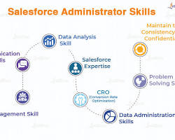

Salesforce Administrator job

* **Salesforce Developer:** Salesforce Developers design and build custom applications on the Salesforce platform. They use Salesforce's API and SDK to create new functionality and integrate Salesforce with other systems. The average salary for a Salesforce Developer is $115,000 per year.

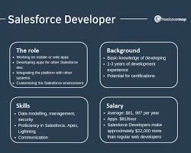

Salesforce Developer job

* **Salesforce Architect:** Salesforce Architects design and implement Salesforce architectures. They work with stakeholders to define business requirements and translate them into technical solutions. They also manage the Salesforce roadmap and ensure that the platform is aligned with the company's overall strategy. The average salary for a Salesforce Architect is $135,000 per year.

[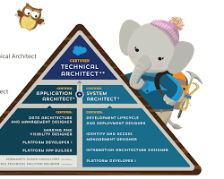](https://www.sfdc99.com/2019/12/03/what-is-a-salesforce-technical-architect/)

Salesforce Architect job

* **Salesforce Consultant:** Salesforce Consultants help organizations implement and use Salesforce effectively. They work with clients to identify their business needs and recommend the right Salesforce solution. They also train and support users and provide ongoing maintenance and support. The average salary for a Salesforce Consultant is $125,000 per year.

[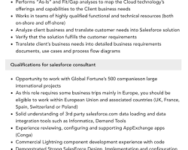](https://www.velvetjobs.com/job-descriptions/salesforce-consultant)

Salesforce Consultant job

* **Salesforce Business Analyst:** Salesforce Business Analysts analyze business requirements and translate them into Salesforce solutions. They work with stakeholders to define business goals and objectives, and they identify the gaps between current processes and Salesforce's capabilities. They also develop functional and technical specifications for Salesforce projects. The average salary for a Salesforce Business Analyst is $110,000 per year.

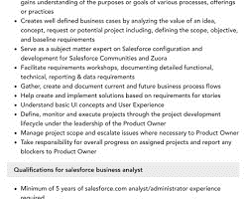

Salesforce Business Analyst job

In addition to these core roles, there are also a number of specialized Salesforce roles, such as Salesforce Integration Specialist, Salesforce Security Specialist, and Salesforce Customer Success Manager. These roles typically require additional expertise in specific areas of Salesforce, such as integration, security, or customer success.

The job outlook for Salesforce professionals is very positive. The demand for Salesforce skills is expected to grow significantly over the next few years, as organizations continue to adopt and expand their use of the Salesforce platform. With the right skills and experience, Salesforce professionals can find well-paying and rewarding careers in a variety of industries.

**HIRING COMPANIES:**

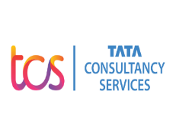 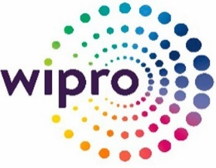  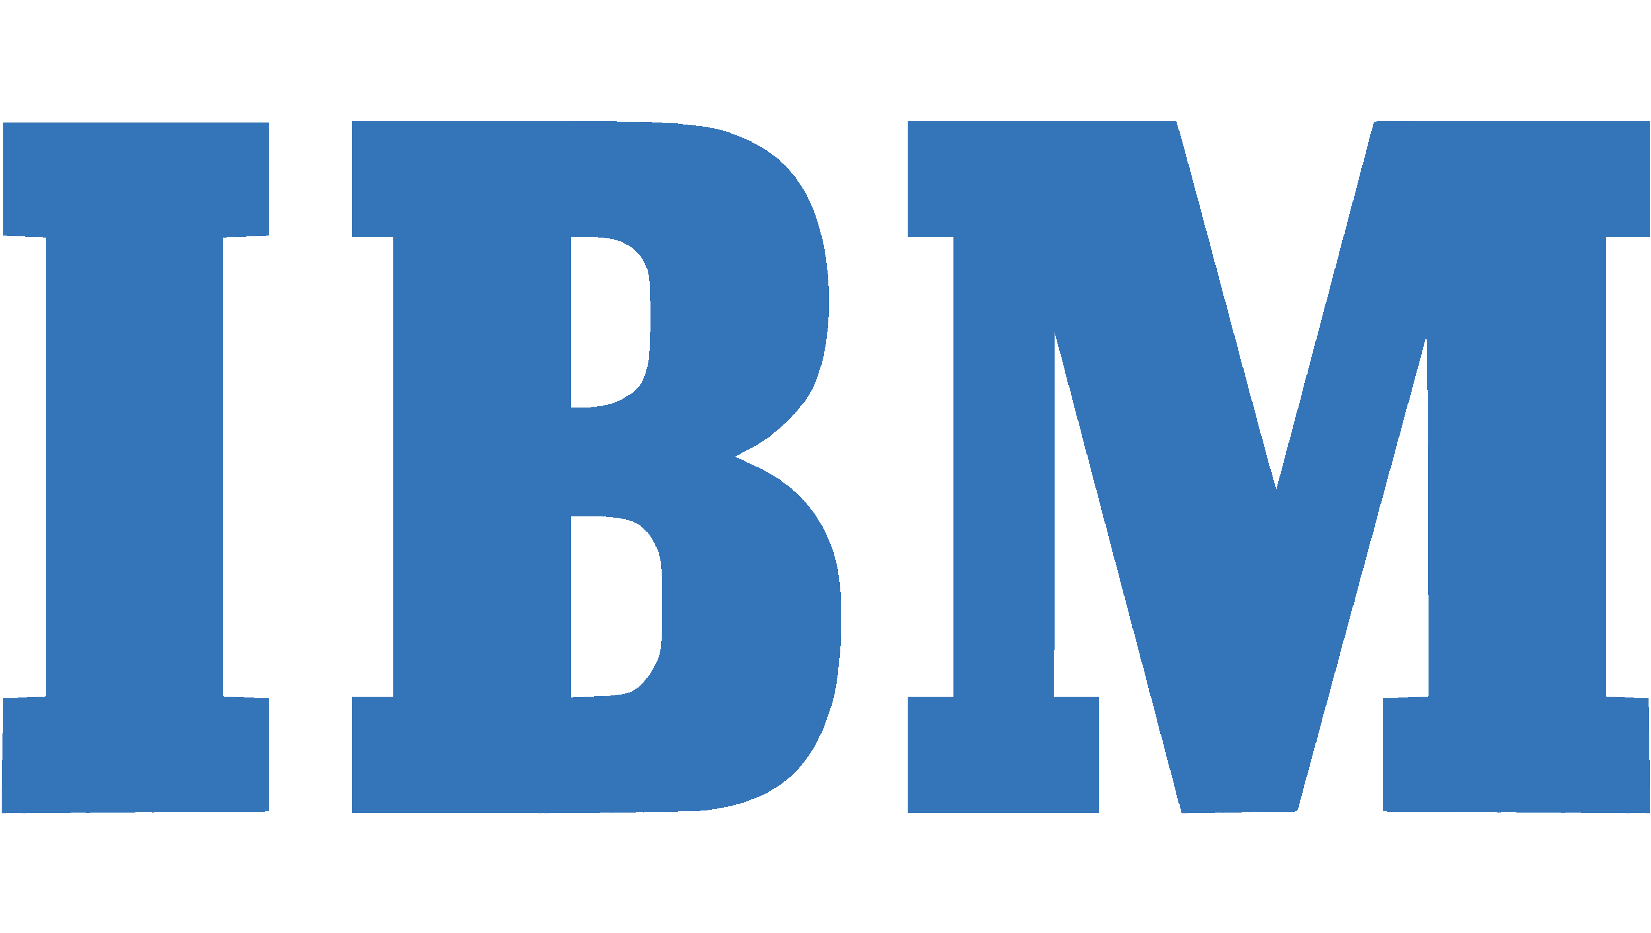 

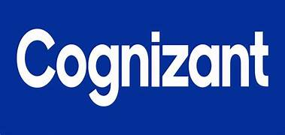   

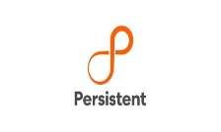  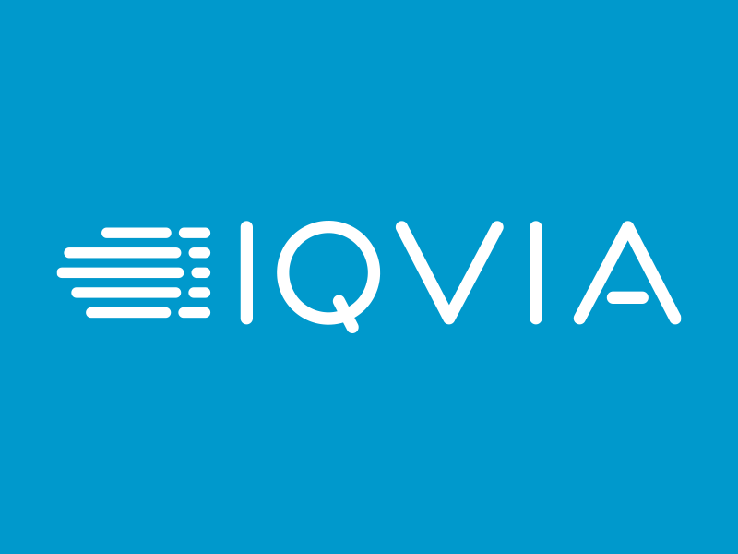 

  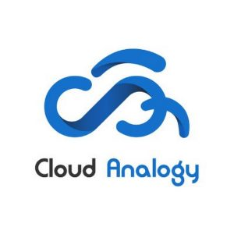 

    

 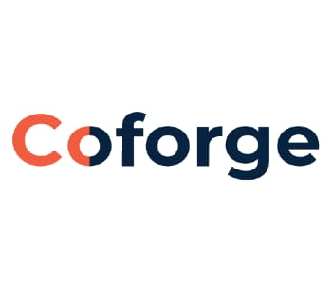  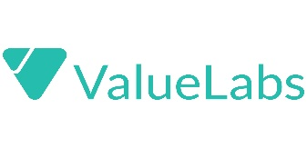 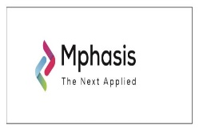

 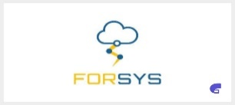 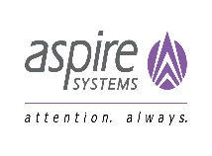 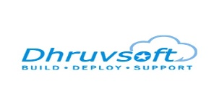 

  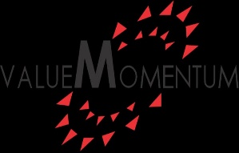 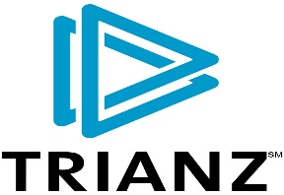 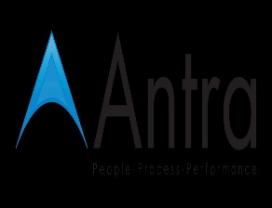

    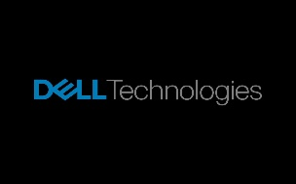

 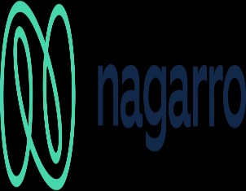   

**PACKAGES:**

Salesforce packages from entry level to experience level

|  |  |  |
| --- | --- | --- |
| Designation | India | |
| **Entry Level** | **Experience** |
| Developer | 2.4 LPA | 10LPA |
| Functional consultant | 3.2 LPA | 15 LPA |
| Platform manager | 4.4 LPA | 49 LPA |
| Solution architect | 4.8 LPA | 28 LPA |
| Technical architect | 13 LPA | 23 LPA |
| administrator | 2.4 LPA | 6.4 LPA |

**Salesforce login:**

**1.In your browser go to** [**https://developer.salesforce.com/signup**](https://developer.salesforce.com/signup)

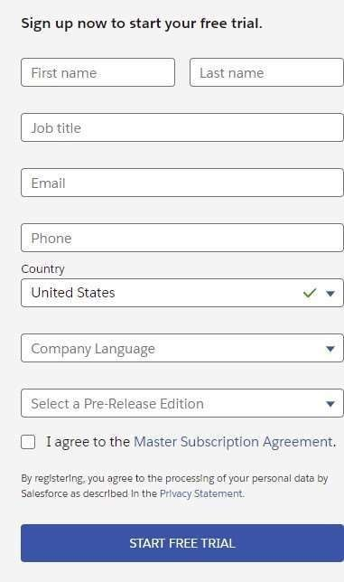

**2.Fill in the fields about you and your company.**

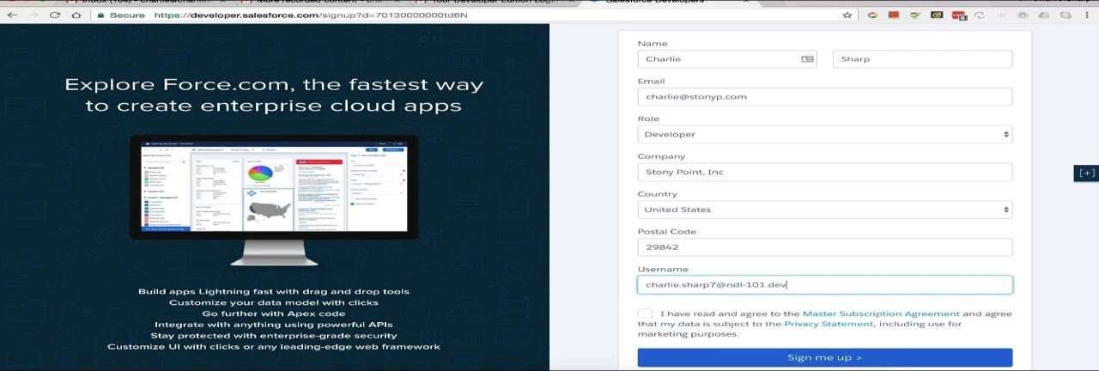

**3.Verify the salesforce account**

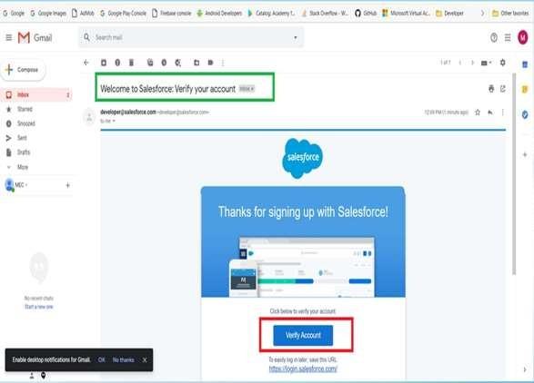

**4.** **We can login in salesforce**

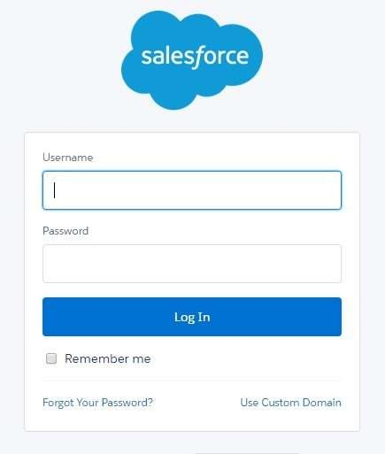

**5.** **After login,it asks to register your mobile number**

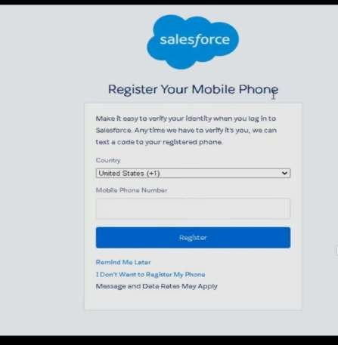

**6. This is the salesforce home page after login into salesforce account**

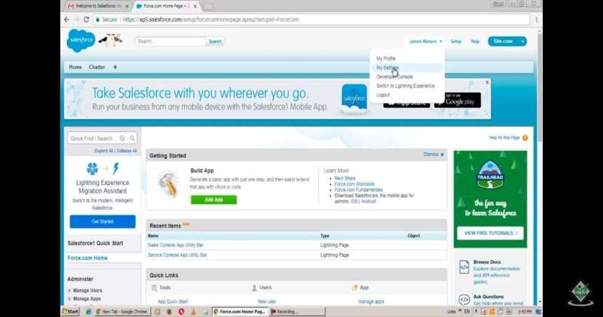

**CONCLUSION:**

* Salesforce CRM has made a business process simple in almost all the industry.
* Taking the business to the next level with increased productivity, exchanging data, using required action for any problem in no time, and anywhere in the world.
* Salesforce CRM will be the future in any domain. Salesforce CRM has made things easier with new technology and up- gradation